**Research Project: Cantril Research**

**Investigator: Kyan Keise**

**Prepared by: Kyan Keise**

**Statement of purpose**

The report is based on the use of the Cantril ladder on data set collected between 2015 to 2019. The Cantril ladder is a tool used to estimate the six factors (levels of GDP, life expectancy, generosity, social support, freedom, and corruption) is likely to contribute towards a country’s overall prosperity.

Cantril Ladder diagram

**Cantril data**

My analysis will be based on a comparison on data gathered between the years 2015 – 2019 which analyses the factors which contribute to a countries Happiness. CSV (Comma Separated Values) is the format of all 5 files. CSV is generally faster and less complicated in comparison to Excel. However, I will be using Microsoft Excel to filter the data Tableau and Juice analytics will be used to present my findings in form of graph representations to conduct my comparisons.

Here is a list of the 158 countries included in each dataset.

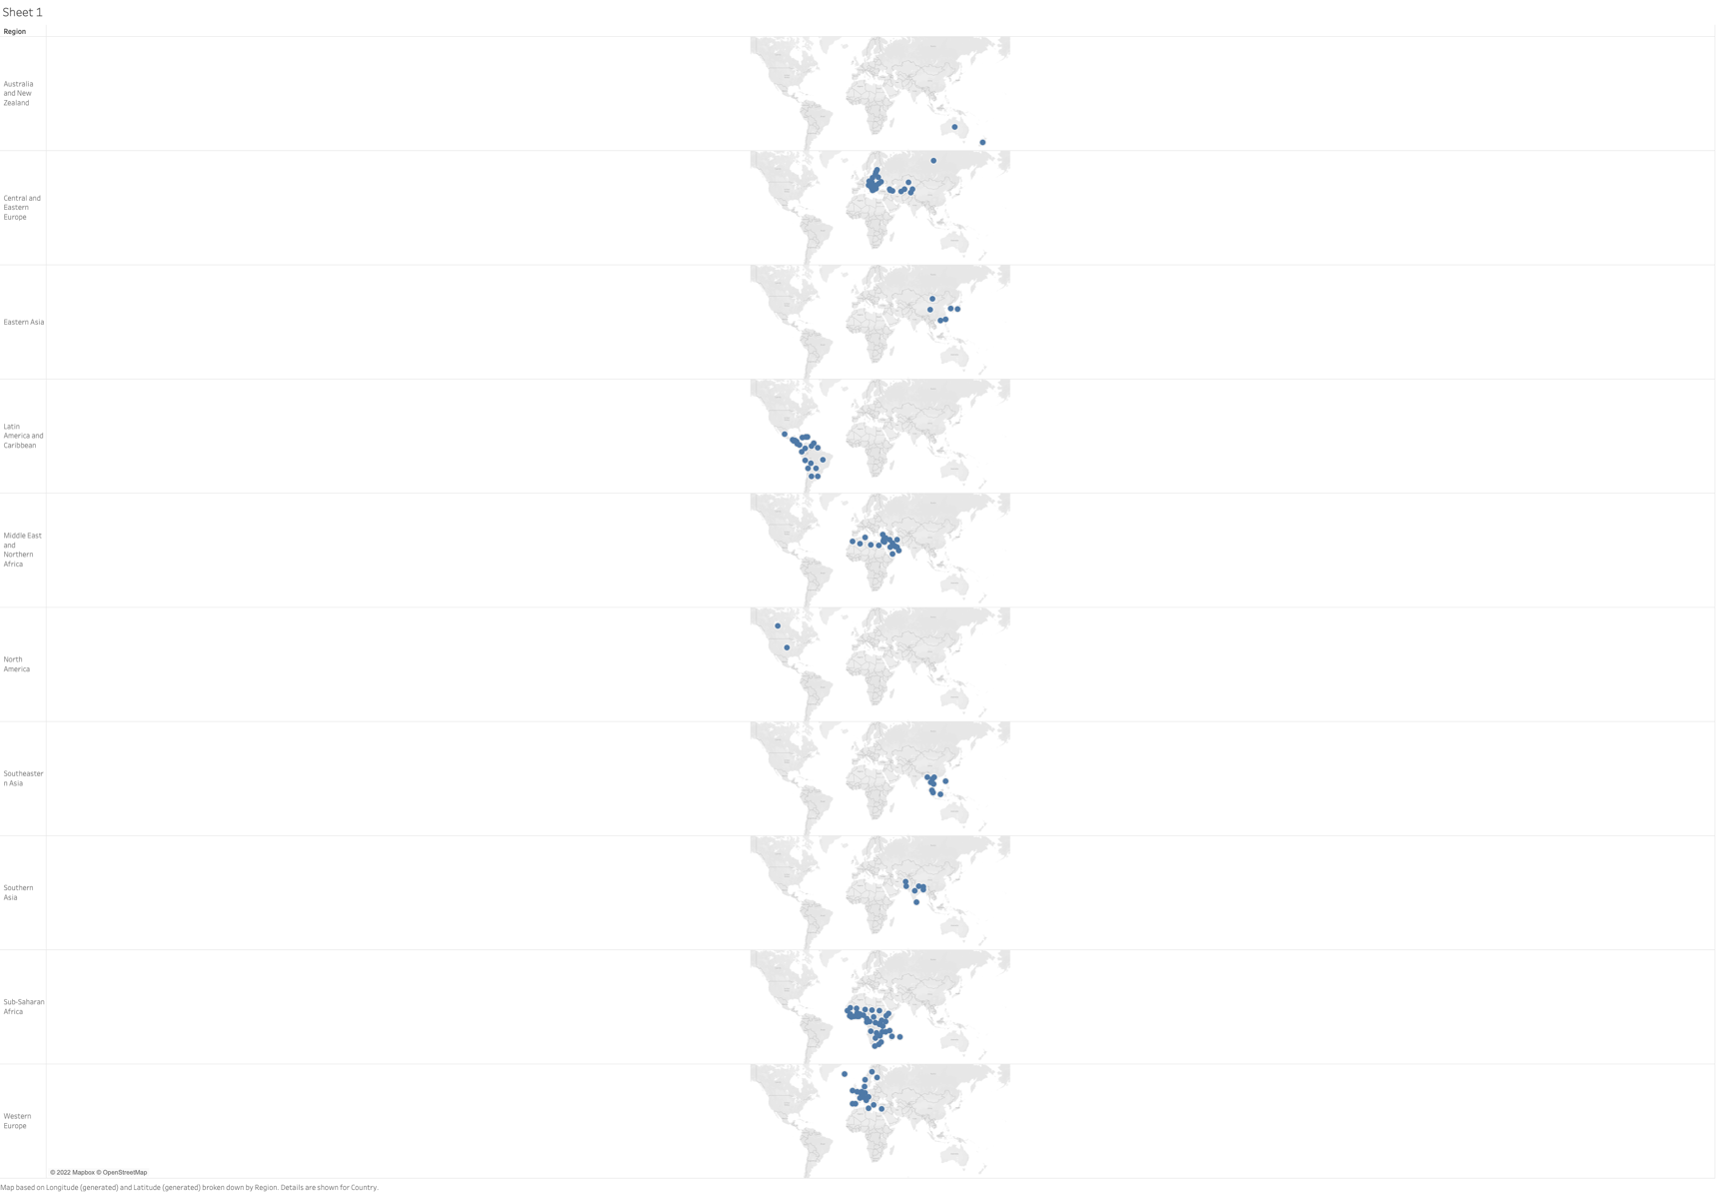

|  |  |  |
| --- | --- | --- |
| Switzerland | Kazakhstan | Lesotho |
| Iceland | Slovenia | Dominican Republic |
| Denmark | Lithuania | Laos |
| Norway | Nicaragua | Mongolia |
| Canada | Peru | Swaziland |
| Finland | Belarus | Greece |
| Netherlands | Poland | Lebanon |
| Sweden | Malaysia | Hungary |
| New Zealand | Croatia | Honduras |
| Australia | Libya | Tajikistan |
| Israel | Russia | Tunisia |
| Costa Rica | Jamaica | Palestinian Territories |
| Austria | North Cyprus | Bangladesh |
| Mexico | Cyprus | Iran |
| United States | Algeria | Ukraine |
| Brazil | Kosovo | Iraq |
| Luxembourg | Turkmenistan | South Africa |
| Ireland | Mauritius | Ghana |
| Belgium | Hong Kong | Zimbabwe |
| United Arab Emirates | Estonia | Liberia |
| United Kingdom | Indonesia | Angola |
| Oman | Vietnam | Mali |
| Venezuela | Turkey | Congo (Brazzaville) |
| Singapore | Kyrgyzstan | Comoros |
| Panama | Nigeria | Uganda |
| Germany | Bhutan | Senegal |
| Chile | Azerbaijan | Gabon |
| Qatar | Pakistan | Niger |
| France | Jordan | Cambodia |
| Argentina | Montenegro | Tanzania |
| Czech Republic | China | Madagascar |
| Uruguay | Zambia | Central African Republic |
| Colombia | Romania | Chad |
| Thailand | Congo (Kinshasa) | Guinea |
| Saudi Arabia | Nepal | Ivory Coast |
| Spain | Ethiopia | Burkina Faso |
| Malta | Sierra Leone | Afghanistan |
| Taiwan | Mauritania | Rwanda |
| Kuwait | Kenya | Benin |
| Suriname | Djibouti | Syria |
| Trinidad and Tobago | Uzbekistan | Burundi |
| El Salvador | Slovakia | Togo |
| Guatemala | Japan | Armenia |
| Portugal | South Korea | Botswana |
| Latvia | Ecuador | Myanmar |
| Philippines | Bahrain | Georgia |
| Somaliland region | Italy | Malawi |
| Morocco | Bolivia | Sri Lanka |
| Macedonia | Moldova | Cameroon |
| Mozambique | Paraguay | Bulgaria |
| Albania | India | Egypt |
| Bosnia and Herzegovina | Sudan | Yemen |
| Serbia | Haiti |

**Techniques used to during analysis**

My findings were based on 5 data sets downloaded from The World Happiness report from 2015 – 2019. After assessing each set, I wanted a representation of which countries featured in the top 50. This was then narrowed down to the top 10 highest performing nations, followed by 10 lowest performers. The idea was to pick up on consistent patterns throughout each dataset which will enable me to carry out comparisons.

**Happiness Chart 2015**

The first section contains a list of the 150 countries who participated in 2015.

The next graph represents the total amount of countries per region. Sub – Saharan Africa contains the highest at 40 followed by central and Eastern Europe at 29.

I wanted to which was the highest region representation among the top 50 performing nations. I obtained this representation by filtering out the countries in the top 50. Which confirms Western Europe and Latin America, and Caribbean are the highest performing nations at 17 and 14 respectively.

**Happiness Chart 2015 Continued**

The next graph represents the 10 highest performing nations. Switzerland are on top followed by Iceland and Denmark. I used a similar technique by filtering out the top 10 countries to produce the representation. It’s very interesting that 50% of this chart are made up of Nordic nations. The findings tell me they must have a way of life which positively impacts their nations happiness.

The next graph presents the 10 performing nations. As you can see sub-Sharan Africa make up 80%. The findings tell me there must survive unrest or a lack of resources which contribute to Africa’s low score.

The last graph is a representation of the highest performing countries per region. I wanted to include this representation as I noticed regions such as North America and Australia/New Zealand feature lowly in the region count due to the fact there are only 2 representatives for each region. Despite this they rank considerable high when compared to the top performing Western European nation Switzerland.

**Happiness Chart 2016**

Here is a presentation on the key findings from the 2016 data set.

This dataset contains slightly more countries at 157

To begin my analysis, I thought it was best to confirm which regions had the best representation. The result confirms Central and Eastern Europe and Sub-Saharan Africa were among the highest representation with 38.27% and 29.20%.

The happiest regions were Western Europe and Latin America and Caribbean similar to 2015.

Denmark finished as the happiest nation, just ahead of last years winner Switzerland 50% of the top 10 still comprise from Nordic regions like in 2015.

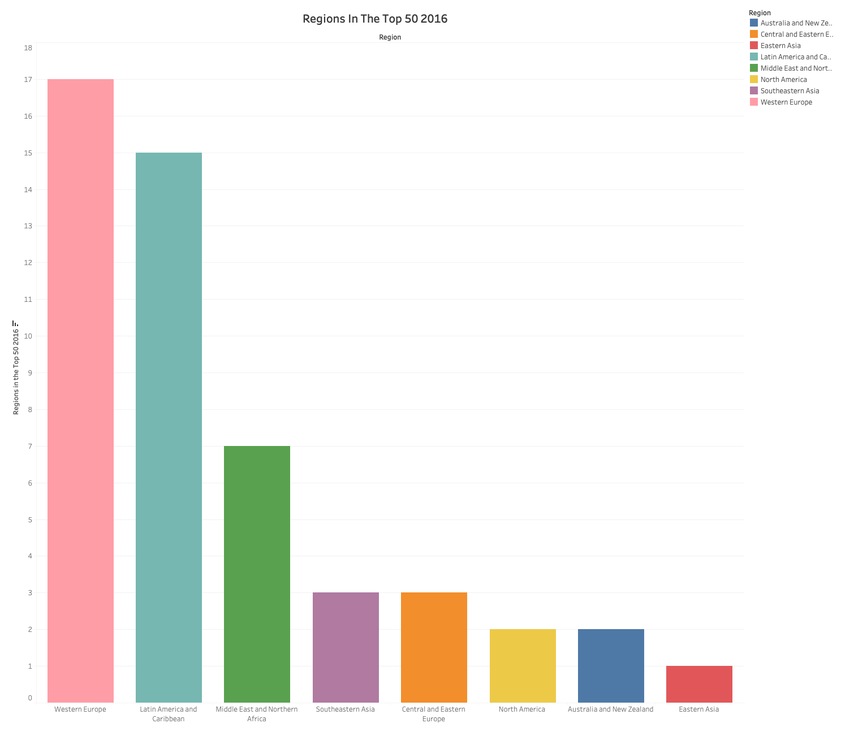

Interestingly the results have changed drastically. Western Europe now has the highest representation with 16.32%. Latin America was a close 2nd with 15.30%. what was interesting was the fact that Central and Eastern Europe contained 3.6% whereas Sub- Saharan Africa contained no entries. these results tell me that despite Western Europe and Latin America having a lower representation in comparison to Central and Eastern Europe and Sub-Saharan Africa, they are a far better representation among the top 50 which tells me both regions contain far happier countries in comparison.

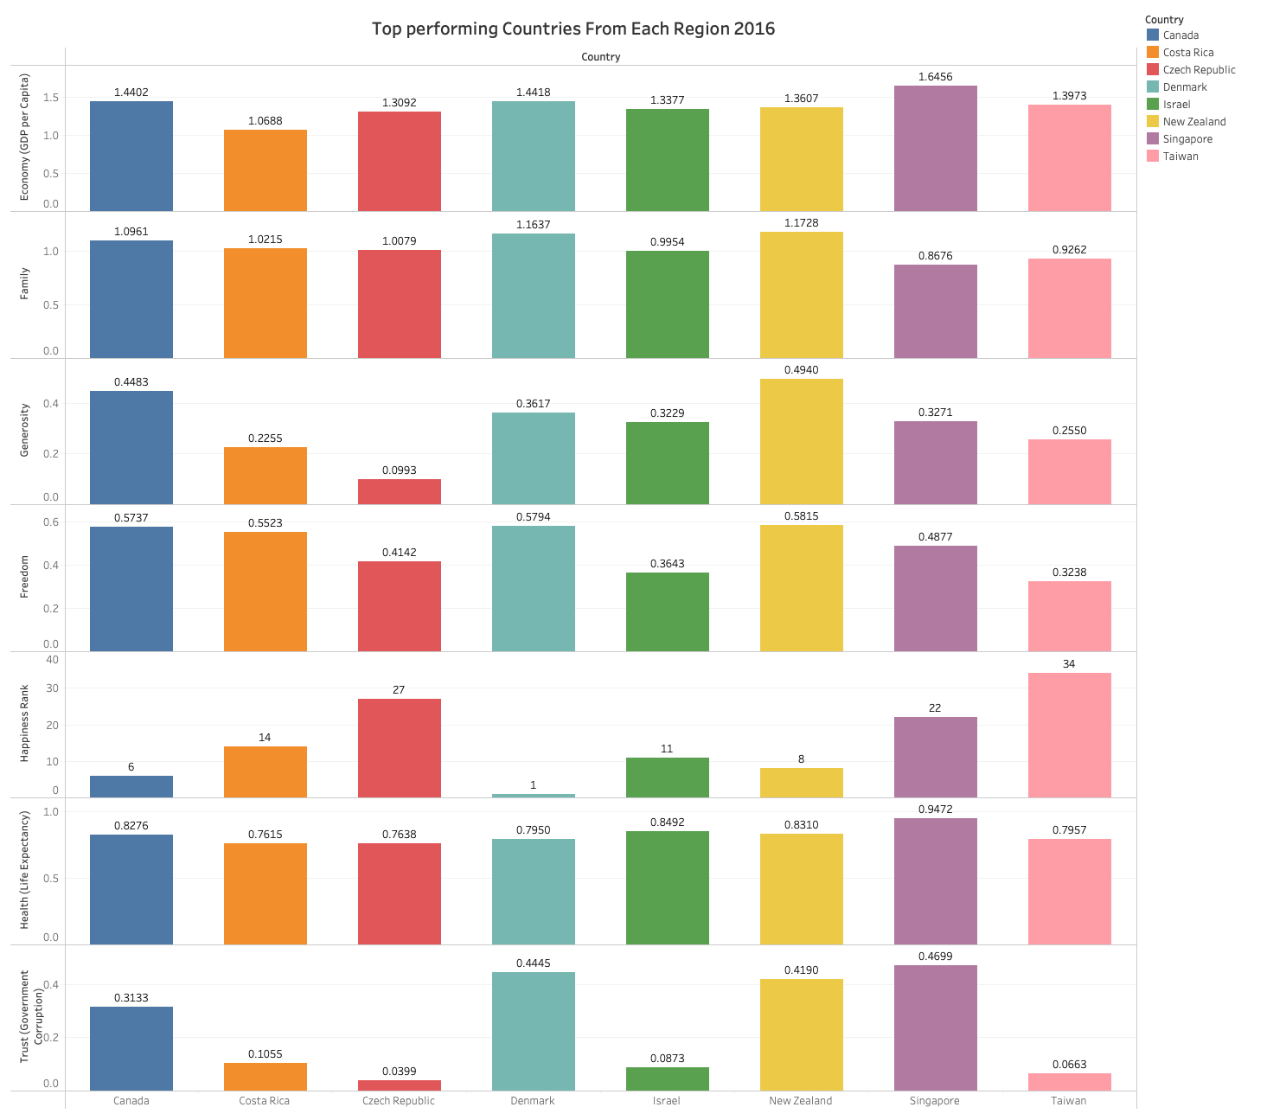

This graph contains a more in-depth look at how the top countries per region compare with one another. All 8 countries have a high GDP score with Singapore leading the way with the highest score of 1.6455. All 8 countries have a similar family score with Denmark and New Zealand with the highest score at 1.1637 and 1.728.

I filtered the data further by manipulating the entries among the top 10. Once again, I opted for the pie chart to showcase my findings. Almost 3 quarters of the entries belong in Western Europe, whilst the rest Is made up of North America and New Zealand. New Zealand. Most of the Western Europe entries reside in the Nordic region. They appear to feature in the top 5 throughout all 5 data sets. Interestingly a report states. The harsh weather could be a major factor in bringing communities together. Together with a high level of trust among the people, government, institutions sand businesses.

I filtered the dataset to return the presence of countries which made up the. Bottom 10. Interestingly Sub-Saharan Africa made up a massive 73% followed by Middle east and North Africa at 18% and Southern Asia at 9%. The findings are reflective on where Sub-Saharan Africa stands today. Where reports suggest a potential rise in fortunes were stalled due to a crash in the price of raw material’s such as crude oil, Iron ore and cooper largely due to the global financial crisis in 2008. Other factors include poor infrastructure and a lack of access to capital.

The Middle East was somewhat of a surprise however during this period a combination of factors such as oil prices hitting a 13 year low together with Civil wars, terrorist attacks refuge inflows.

**Graph analysis**

I made use of 3 graphs when conducting my analysis. Those 3 car Line graphs, bar charts and Pie charts. These are the three I felt were best suited for this project.

I used a bar chart to compare the performance of leading Western country Switzerland in comparison to the leading Sub- Saharan African country Mauritius. I manipulated both Switzerland and Mauritius dataset, by filtering out the information not required whilst drafting a mini table with the required information. They are easy to understand and really helps the user understand how each country performs in under each category.

I used a pie chart to compare the region count that make up the 2016 dataset. The pie chart was best used for this analysis as it helps the user understand the information quickly, and it shows the percentage of each region that makes up the 2016 dataset.

I used a line graph to represent the GPD of the highest performing country in comparison to the lowest. the line graph provided suitable in these circumstances as the data was gathered across all 5 data sets. It really helps the user understand the stark differences between the two countries.

**Data analysis findings**

Following on from my findings I wanted look closer at Switzerland to understand why its consistently featured in the top among all 5 datasets.

The GDP shows a steady rise from 2015 to 2017 before a sharp drop in 2018 before a steady rise continues again. Interestingly Switzerland was placed in position 1 in 2015 despite having its lowest GDP score. Whereas at its highest in 2017 it was ranked 4th. This tells me that clearly a combination of factors influences a countries happiness. Whilst GDP Is essential to a countries value from a product or service, I want to look further into the other factors influencing Switzerland’s high score.

In this graph I collected the GDP and family support of Switzerland from 2015 - 2019

[Include a line Graph of the other Cantril measures within Switzerland]

**Comparisons**

After assessing all 5 datasets I created a series of graphs which highlight countries who have performed well over the period. Those who have remained consistent followed by those that have performed poorly. The steps taken to fulfil this, were filtering copying the stats from all the key attributes per country as some datasets. I

rounded the datasets from 2017 – 2019 to the nearest 3 d.p to fall in line with the data from the other two sets.

**Chad**

As you can see Chad has made dramatic improvements over this period. Going from a lowly 150 in 2015 to a high of 138 in 2018.

Looking at the key attributes the first graph showcases a gradual increase in trust over time.

GDP has surprisingly decreased towards the end of the period. This tells me other factors have contributed more to this nation’s happiness.

Family has produced a stark increase from 2016, where It has remained steady onwards.

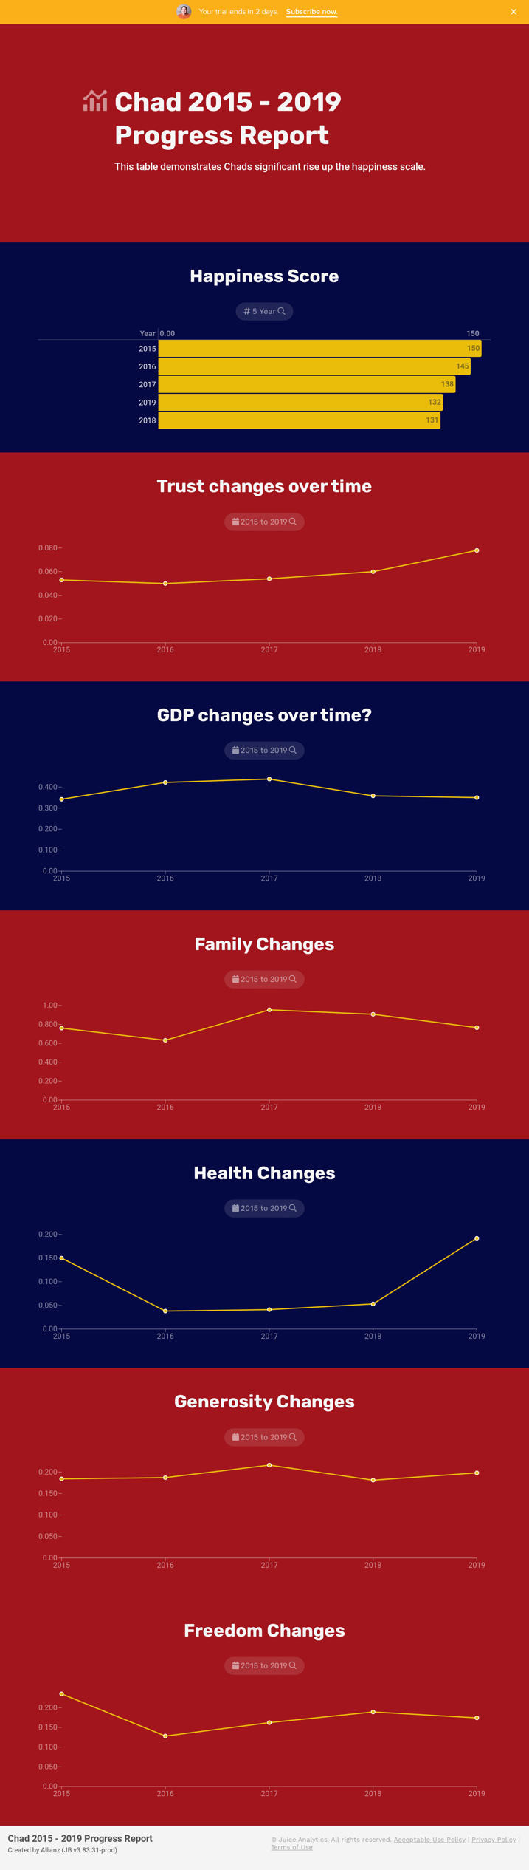the nation’s health has also been on the increase since 2016 before rising sharply in 2019.

Generosity seems to have hit a slight increase in 2017 before remaining steady throughout.

Whilst freedom endured a stark decrease in 2016 It appears to have improved steadily since.

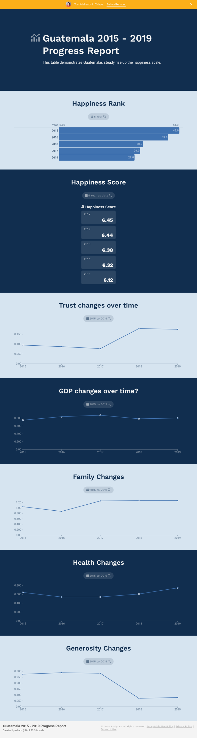

**Guatemala**

Guatemala is another nation which has improved of the 5 year period.

Trust has seen a stark increase whilst GDP have remained stable. This is a similar pattern as Chad. It seems as if trust may carry a more significant impact to a country’s nation so far.

**Guatemala continued**

Family have made improvements since 2017 before stabilising moving forward in comparison to Chad which saw a slight decrease.

Health has taken a gradual increase since 2017 whilst not as dramatic as Chads increase 2018 still an increase non the less.

The stark difference between the two is the generosity has taken a nosedive since 2018. The nations happiness has sill increased despite this so maybe generosity is another factor which doesn’t significantly improve happiness.

Freedom has been stable throughout the period; however, it has showcased a slight decline since 2018.

**Malta**

Malta is another nation that have improved over the 5-year period. Malta have consistently increased their happiness rank over the period where they now sit at 22.

It has seen year by year increasing in its happiness score like Guatemala.

**Malta continued**

Unlike the first two nations Malta trust levels increased during 2016 before taking a slight decline before another gradual increase. Like Guatemala this hasn’t affected the happiness score as its continued on a upward trajectory ever since.

GDP levels are very stable in comparison to the others. Other than a slight dip in 2018 its has been very steady throughout.

Social support appears to have taken a slight decline in 2016 before gradually improving from that point onwards.

Life expectancy has increased consistently since 2016, whilst generosity appears to have suffered a sharp fall during 2018. Before stabilising in 2019.

Freedom has also been relatively stable. Malta’s performance appear to be steady in every category which could possibly explain its steady rise up the happiness table.

**Italy**

Italy have also endured a year-on-year increase. They have jumped from rank 50 to 36 over the period.

Trust seems to be stable year on year with only slight changes. GDP is the same a slight decrease in 2018.

**Italy continued**

Social support has seen a respectable jump since 2016 which could contribute to their increase in happiness.

Life expectancy has also shown a key improvement since 2016. Italy are renowned to have a longer life expectancy based on their favourable Mediterranean diet as well as being very family orientated.

Generosity and freedom appear to experiences falls and subtle increases throughout.

**Canada**

Canada is one of the only nations which has featured in the top 10 throughout the whole period with 9th being its lowest performance in 2019.

Trust appears to hit a peak in 2017 before lowering to levels similar in 2015 – 2016.

GDP appears to be very stable throughout.

**Canada Continued**

Social support took a slight hit in 2016 before improving every year after.

Life expectancy has also seen a year-by-year increase since 2016.

Generosity levels have taken a tumble especially when comparted to the other factors. Most nations on the rise appear to showcase decreases in generosity.

Freedom levels appear to be stable before taking a slight decrease in 2019.

**Venezuela**

Unlike the others Venezuela has experienced one of the most dramatic drops in the happiness score. They have fallen from rank 23 to 108 during the period.

There happiness score appears to have gone from 6.811 to 4.71.

Trust appears to have experienced a consistent decline throughout the period.

GDP however appears to be stable. It appears GDP doesn’t have as much of an effect on the overall ratings in comparison to other factors.

**Venezuela continued**

Social support has surprisingly appeared to have increased every year since 2016.

Life expectancy has also slightly increased. Whilst generosity has been up and down. Freedom appears to have taken a big hit since 2015.

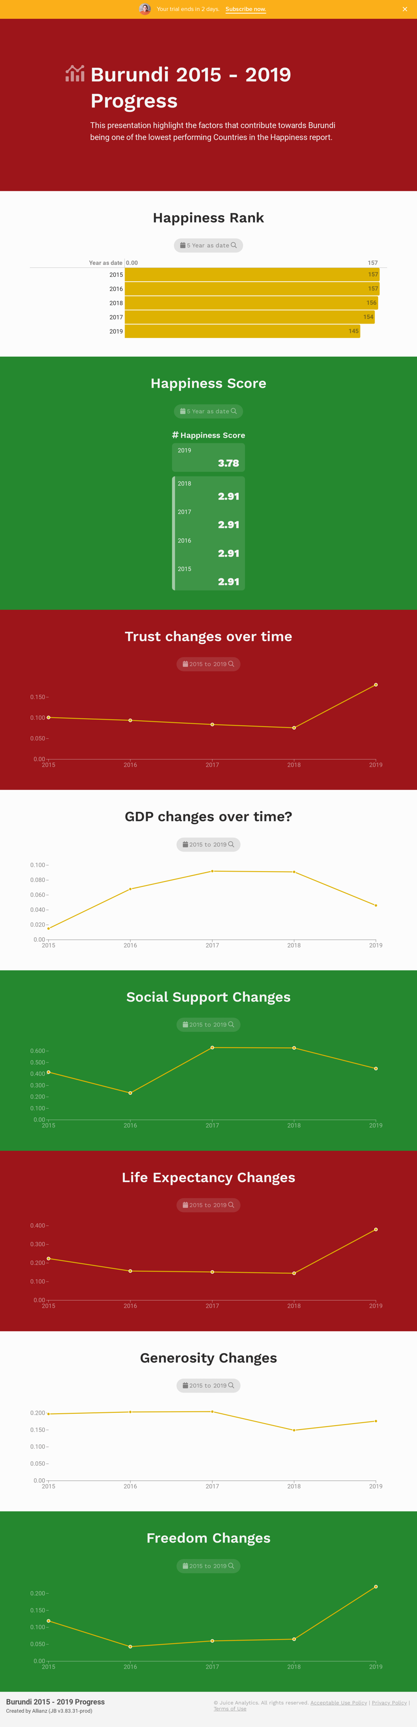

**Burundi**

Burundi had started off as one of the worst performing teams on the list, although they experienced a slit increase in 2019, they remain one the worst performing throughout the period.

Surprisingly except for 2019, Burundi’s Happiness score has been recorded as 2.91.

Trust levels were on the decline, however 2019 showcased a sharp increase.

**Burundi continued**

GDP appears to improve before taking a sharp decrease in 2018.

Social support appears to dip during 2016 before increasing again in 2017. It then begins to slightly decrease once again.

Life expectancy appeared to be on the decline. 2019 however showcased a sharp increase in 2019.

Generosity levels appeared to be stable before taking a slight nosedive in 2017. It gradually begins to pick up again in 2017.

Freedom levels also experienced sharp increases after 2019 which might explain its sudden increase in freedom.

I have noticed through most of the improving country life expectancy seems to have more of an effect on the happiness score then other elements such as GDP.